Thriving as elders is not just about filling our time - it’s about how we lead a fulfilling life over time. It’s about how we face the realities of aging and its often disorienting change, while continuing to find and sustain meaning and satisfaction throughout our elder years. Together, working with an evidence-based framework, we'll explore relevant research; we’ll share our wisdom and strategies, deepen practical skills, expand possibilities and create a personal legacy and mission. This generative process is designed to stimulate introspection and insight, motivate and guide us to be more intentional about our choices, and illuminate how we are growing and showing up in the world for ourselves and others.

Benefits/Outcomes
Your participation in this conversation promises to enrich your capacity to thrive as an elder. Outcomes include:

- Have greater clarity about what drives your choices and why this matters
- Learn proven strategies to handle fatigue, isolation and loss with grace
- Practice powerful skills to connect and refresh your relationships
- Be inspired with more possibilities
- Strengthen your intentions to live your legacy and embrace your mission
- Honor and celebrate continuous growth

Aging is not lost youth, but a new stage of opportunity and strength. ~ Betty Freidan
Aging is an extraordinary process whereby you become the person
you always should have been. ~ David Bowie

____________________________________________________________________________________



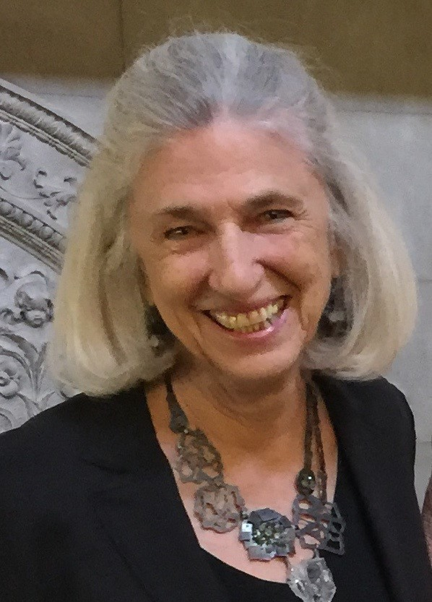
Barbara Beizer

B2Works | Conversations That Matter
Leadership & Transition Coaching
B2beizer@gmail.com | 202.669.0800
https://www.linkedin.com/in/b2beizer/

I’m a certified coach, working with people who wish to grow and thrive as human beings and leaders. My practice draws on decades of business and non-profit leadership, graduate study in organizational psychology and change, a variety of traditions and research, an eclectic array of tools, and finely-honed intuition. I was a Peace Corps volunteer in India, and for more than ten years after 9/11, co-facilitated multicultural interfaith community dialogues. Since leaving the corporate world, I’ve designed and delivered more than a hundred workshops on resilience, transition and related topics, and have created this series on Thriving as Elders, especially for OLLI members.

Thriving as Elders: The Adventure Continues
Workshop Description – OLLI Shorts Proposal – Feb 2025

Study Group Outline for 5 Sessions, 90 minutes each

There may be suggested short readings, videos or exercises of no more than 15-30 minutes duration between some sessions.

Session 1 – Framework
Revealing the power of positivity and perspective
Engaging peak experiences

Session 2 - Focus
Deepening relationships and connection
Reaffirming personal values

Session 3 - Fabric
Finding meaning
Living my legacy

Session 4 - Flair
Reframing accomplishment
Creating my personal mission

Session 5 – Flourishing in elder-essence
Sustaining vitality and energy
Keeping it green

